

Cluster Mapping & Household Listing Guide
This manual is for cartographers and other relevant core team members that will be working on baseline mapping and listing activities. This manual will cover basic procedures, tools, challenges, and good practices for baseline mapping conducted by cartographers, and population listings conducted by data collectors.
Cluster Mapping & Household Listing Basics
Cluster mapping and population listings help create baseline population counts and demographic rates. Baseline data provides accurate estimates of sample populations, allows for quality control of births and deaths, and can provide a sampling frame for future surveillance activities.
Products of Cluster Mapping and Household Listing
Using the example of SIS-COVE Mozambique, proper mapping and listing of clusters, should result in the following products:
1) GPS coordinates of the cluster (centroid and polygon)
2) GPS coordinates of each household in the cluster
3) List of each household with name of head of household and number of persons living in the household, disaggregated by sex and age group of interest such as under-5, 5-14 or 15 and above
4) Assigned household IDs
What is an enumeration area?
Enumeration areas (EAs) are geographic areas that are outlined for use in a housing and population census. EAs are often organized into neighborhood blocks that are adjacent to one another An EA contains between 100 and 150 households in urban areas and 80 to 120 in rural areas.
What is a cluster?
A cluster is the term SIS-COVE Mozambique uses for the control areas, derived from the country’s census enumeration areas. A control area contains between 2 to 5 EAs. Each SIS-COVE cluster ideally contains around 300 households.

Software Needed
Cartographers and data collectors will need tablets or phones to collect GPS coordinates and household information through a data collection application, such as ODK Collect. The GPS coordinates, with defined cluster boundaries, should be uploaded to a GIS-supported application, such as Geopaparazzi. The image below shows 5 EAs, making up 1 cluster.
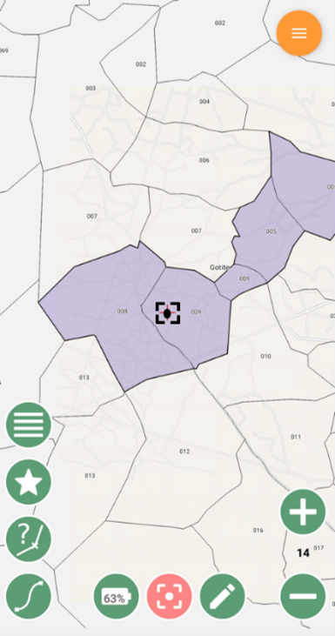
Screenshot from Geopaparazzi with a segmented cluster.
Examples of open-source GIS applications:
- Geopaparazzi
- QGIS
- GRASS GIS
- Whitebox GAT

Procedures
Using the Cluster Mapping Paper and ODK Tools (see under Step 5 Resources):
- Visit each household in a cluster to collect the following information:
  - Take the GPS Points of the household
  - Name of the head of household
  - Number of Males
  - Number of Females
  - Number of children under 5 years
  - Number of children 5-14 years
  - Number of adults 15 years and above
- Walk around the boundaries of the EA to pick GPS points to create a GPS polygon for the EA. The activities above are repeated in each EA until you obtain the number of households required for data collectors to work efficiently.
- For SIS-COVE Mozambique, we aimed to map 300 households in each cluster, and no partial mapping of settlements was allowed.

